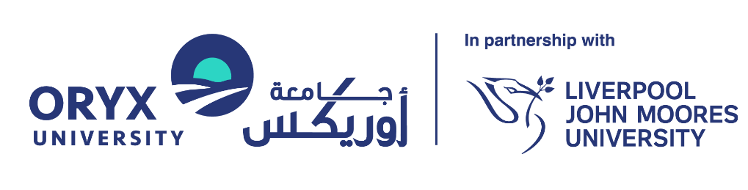

COLLABORATION REVIEW INITIATION FORM
ORYX UNIVERSITY
In Partnership with Liverpool John Moores University

Document Reference: | RKEO-FRM-Collaboration Review Initiation
Version: | 1.0
Effective Date: | 14 February 2026
Review Cycle: | Annual
Next Review Date: | 14 February 2027
Document Owner: | Director of Research and Knowledge Exchange
Responsible Office: | Research and Knowledge Exchange Office (RKEO)
Approved By: | University President

Version History
Version | Author | Description of Changes | Date
Version 1.0 | Dr. Maher Salem | Created the first version | 12 Feb 2026

Purpose: To initiate the governance, legal, and due diligence review for a proposed external partnership. No agreement may be signed until this review is complete.

PARTNER DETAILS
Filed | Response
Partner Organization Name:
Partner Type: | [ ] University  [ ] Industry/Private Sector  [ ] Government/NGO
Country:
Key Contact Person:

SCOPE OF COLLABORATION
Field | Response
Proposed Activity: | [ ] Joint Research Project  [ ] Student Exchange/Placement  [ ] Joint Conference/Event  [ ] Data Sharing Only  [ ] Other: ____________________
Brief Description of Scope (100 words):

Duration: | Start:  End:

RISK & GOVERNANCE CHECKLIST
Field | Response
Financial Implication:  Is Oryx University required to pay or receive funds? | [ ] Yes  [ ] No
Data Sharing: Will personal or sensitive data be transferred to this partner? | [ ] Yes  [ ] No  If Yes, Data Residency compliance (Qatar Law No. 13) check is mandatory.
Intellectual Property:  Is joint IP creation expected? | [ ] Yes  [ ] No
Reputation:  Are there any known controversies associated with this partner? | [ ] Yes  [ ] No

RKEO REVIEW (OFFICE USE)
Due Diligence Check: [ ] Pass [ ] Fail
Legal Review Required: [ ] Yes [ ] No
Recommended Agreement Type:
[ ] MOU
[ ] NDA
[ ] Research Agreement
[ ] Service Contract

RKEO Director Sign-off: __________________________ Date: ___________

